BioRubeBot Sandbox Simulator

Developer Startup Guide

For Dr. Sara Cline (Athens State University)

Rev 1.0

Friday, November 27, 2015

Prepared by CS452 Senior Software Engineering Project

Instructor: Adam Lewis

Fall 2015

Table of Contents

1. Developer Tools
   1. What is Unity?
   2. What is GitHub?
2. Installation Instructions
   1. Unity
      1. System Requirements
      2. Getting the right version of Unity
      3. Create a free Unity Account
      4. Installing Unity x.x.x
      5. Using Unity x.x.x
   2. GitHub
      1. Getting the newest version of GitHub
      2. Create a Free GitHub Account
      3. Installing GitHub
      4. Using GitHub
3. Online Documentation
4. References

Developer Tools

What is Unity?

**Unity** is a flexible and powerful development platform for creating multiplatform 3D and 2D games and interactive experiences. It’s a complete ecosystem for anyone who aims to build a business on creating high-end content and connecting to their most loyal and enthusiastic players and customers.

What is GitHub?

**GitHub** is a Web-based Git repository hosting service. It offers all of the distributed revision control and source code management (SCM) functionality of Git as well as adding its own features. GitHub provides a Web-based graphical interface for both desktop and mobile integration, and also provides access control and several collaboration features such as bug tracking, feature requests, task management, and wikis for every project.

Installation Instructions

Unity

System Requirements

For a general list of system requirements go to: <https://unity3d.com/unity/system-requirements>

Getting the right version of Unity

The Project is currently built under version 5.1.2f1, the decision to upgrade the project is up to the team in charge of the project.

First, go to the download site for unity at <https://unity3d.com/get-unity/download/archive> and download the respective version of Unity you will be using for the project. There are options for both Mac and Windows as well as 32/64 Bit for their respective platforms.

*Note: If you decide to use any version other than the current version, upgrading sections of code might be necessary.*

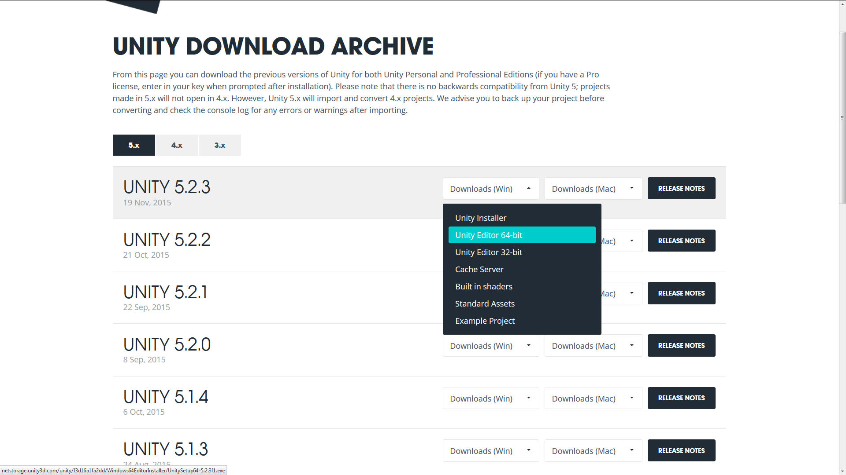

Creating a free Unity Account

Next up is creating a free Unity Account as Unity requires an account to use to their software. Go to <https://accounts.unity3d.com/sign-up> and create your free account.

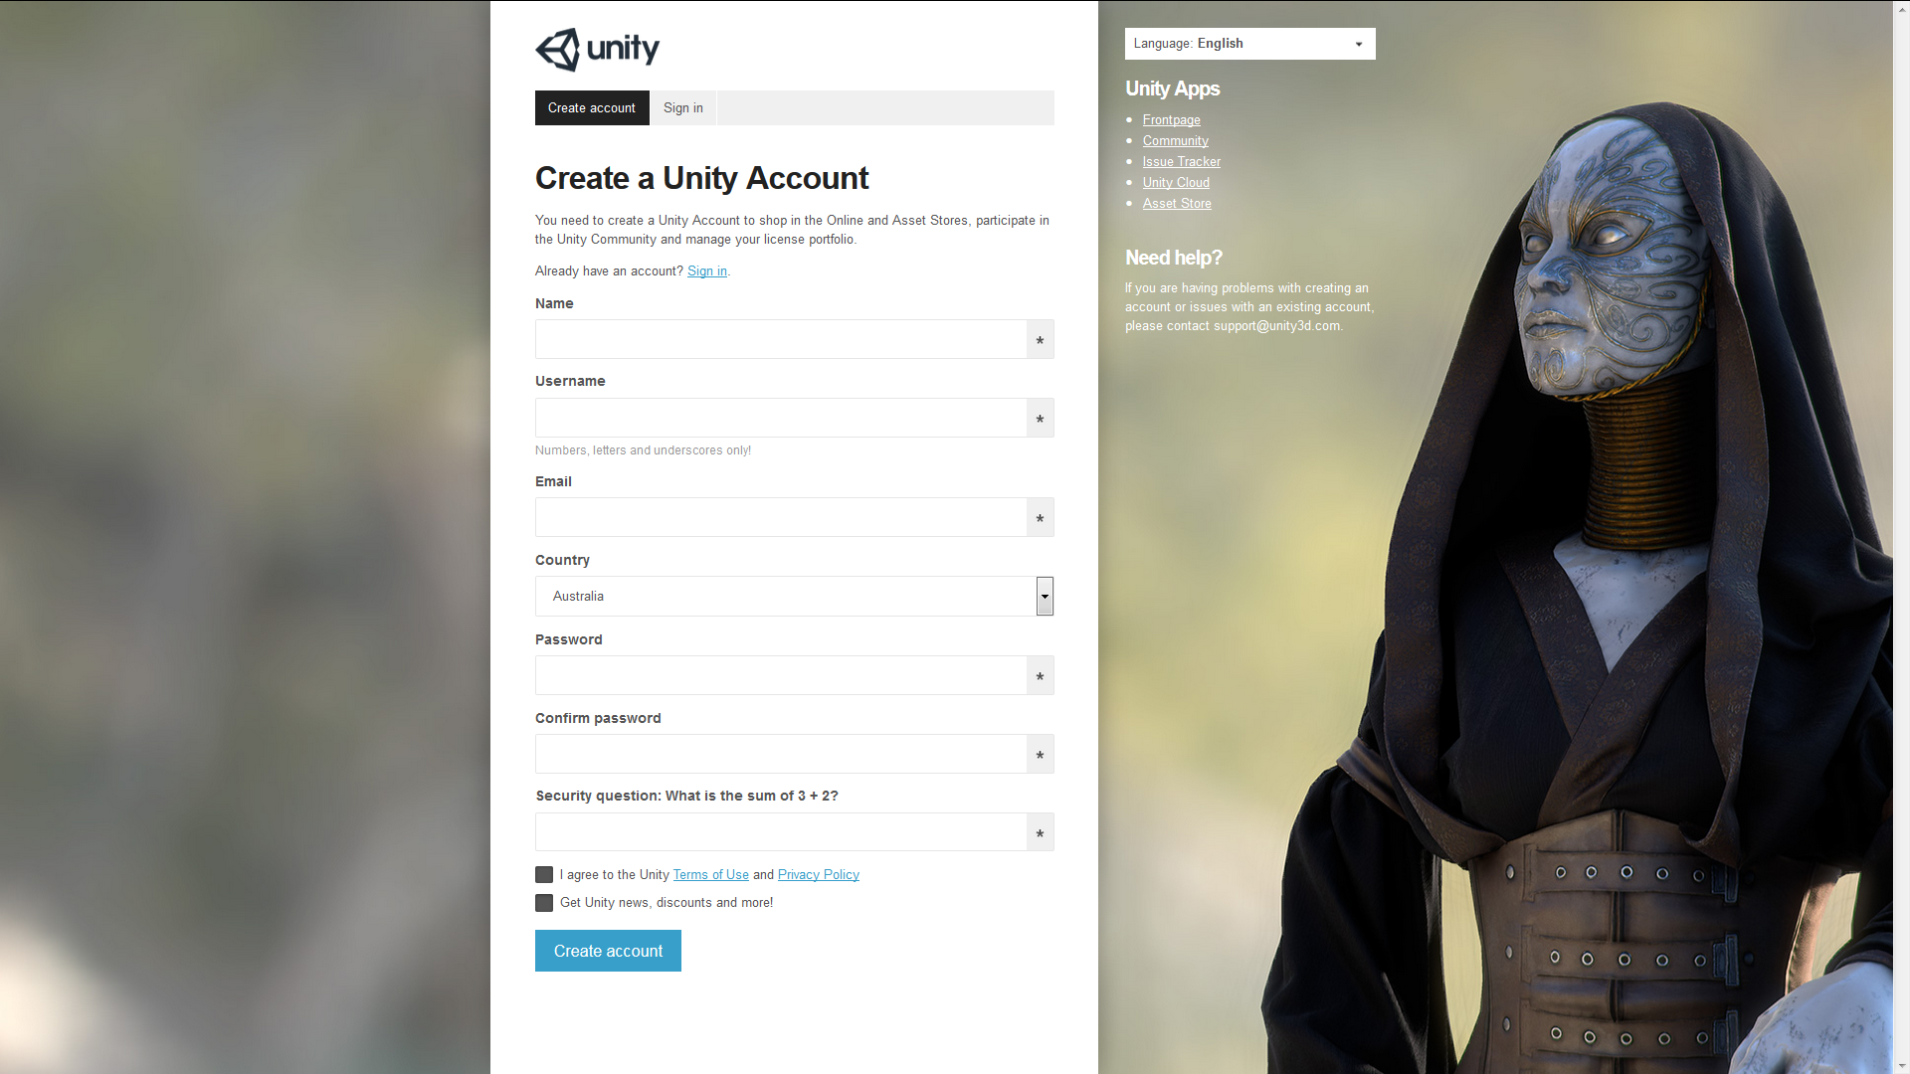

Installing Unity x.x.x

When your unity install file finishes downloading, go ahead and start up the installation file. If installing on windows, a security warning will likely appear. Click Run.

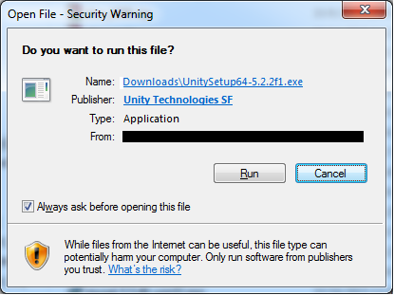

After clicking on run, the Unity Installer will launch. Click Next in the bottom right to continue.

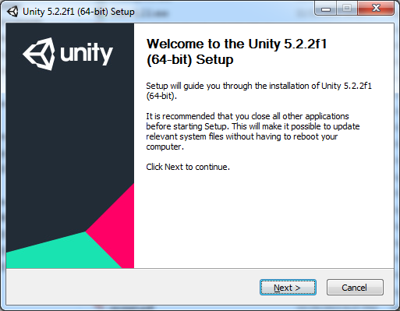

The Unity install with then show you the standard licensing and user agreements. Click next to continue.

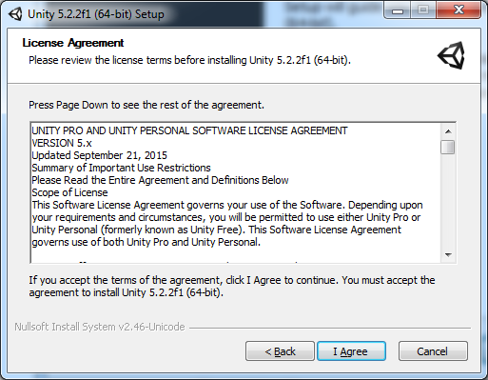

Next will be to choose the options you want installed. Click Next to continue.

*Note that if you plan to use Visual Studio as the debugger for the project, uncheck the MonoDevelop IDE.*

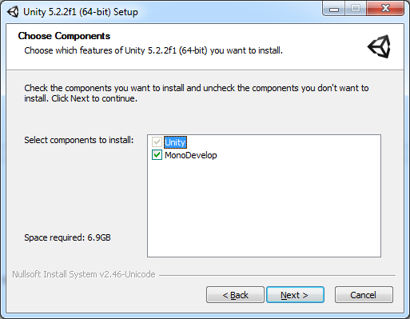

Next will be to give Unity an install directory. After that just click install and Unity will be installed.

*Note that you need at least 6.9 GB of install space to install Unity.*

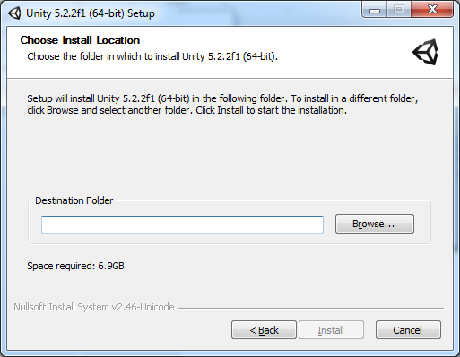

Using Unity x.x.x

After Unity is installed, open Unity. When you open Unity it will likely ask for you to log in to activate your installation. Even though Unity is free, they want to keep track of who is using their software. Simply login using the account information you created previously.

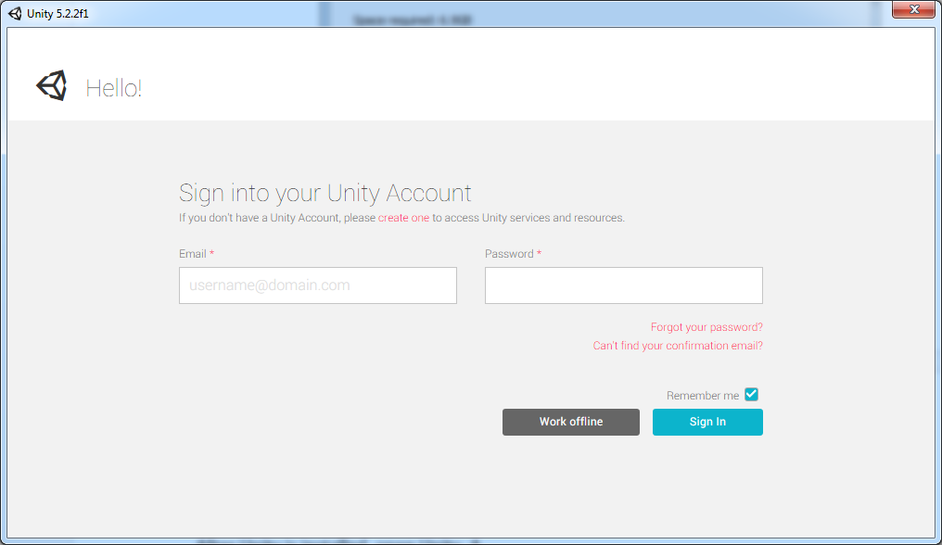

After logging in, this screen will appear. On this screen, either choose to create New Project or Open Other to open an existing project. (Need to be sure to download the latest version from GitHub to proceed.

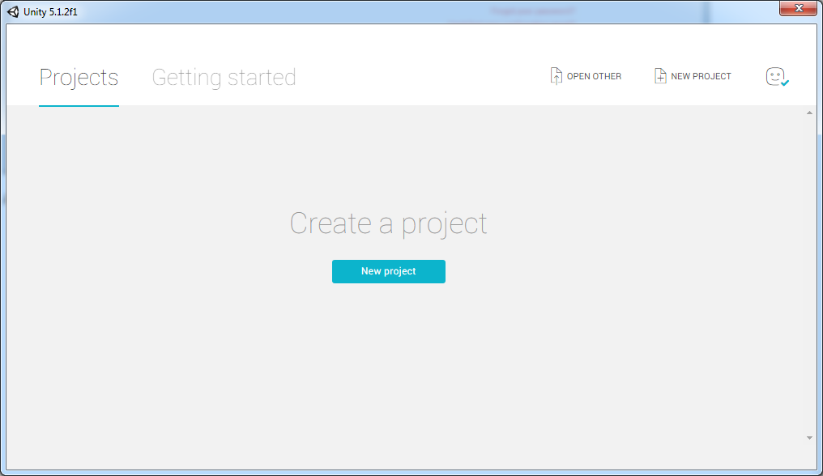

Next, navigate to the project folder. Select the folder and click Select Folder

*Note: DO NOT enter the folder as Unity executes projects from the top level folder directory)*

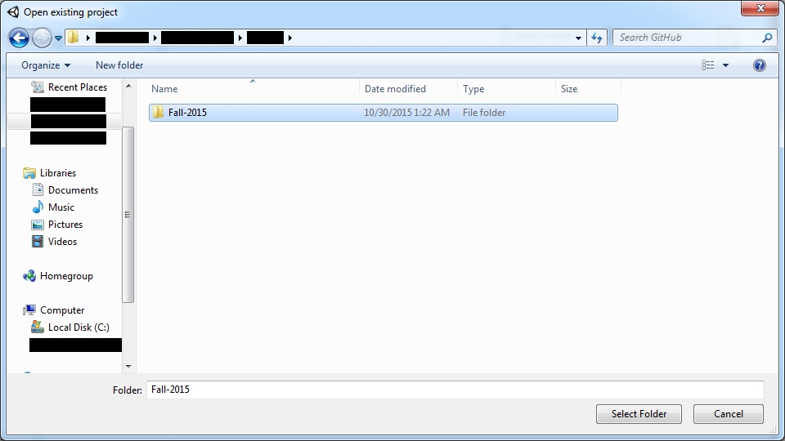

After opening the project, it is ready to start working with. Congratulations!

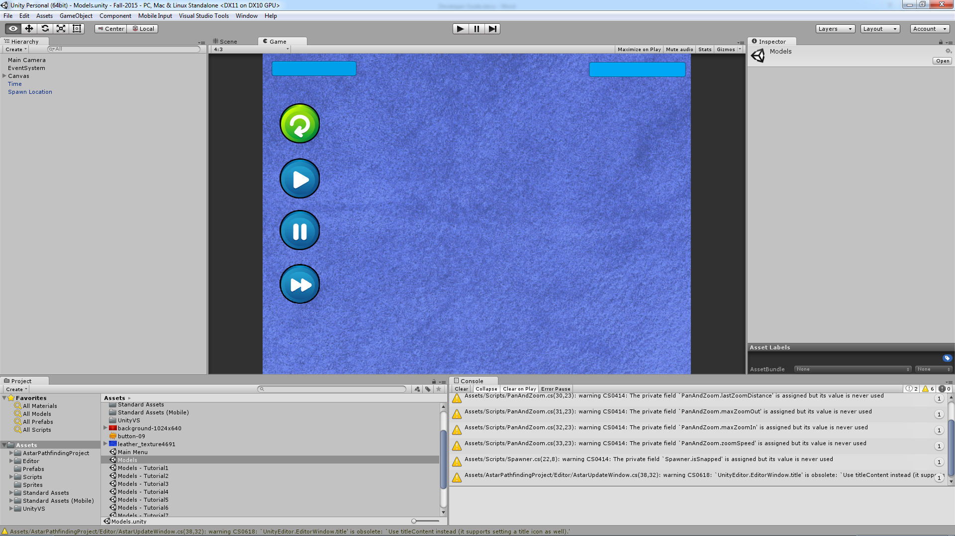

GitHub

Getting the newest version of GitHub

First, go to the download site for GitHub at <https://desktop.github.com/> and download the newest version of GitHub.

*Note: It is important to keep up to date on GitHub!*

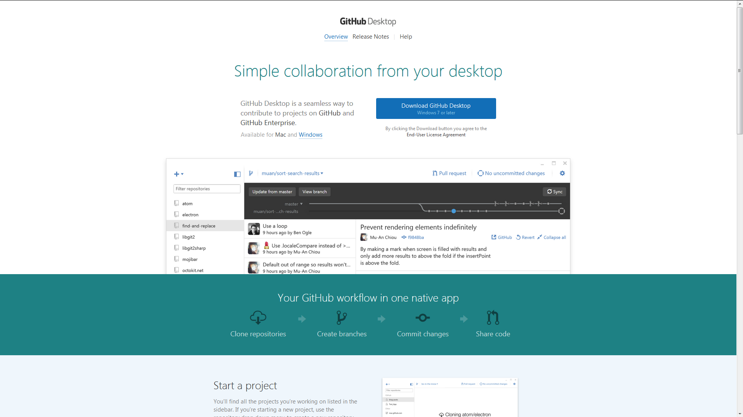

Creating a free GitHub Account

Next up is creating a free GitHub Account as GitHub requires an account to use their software. Go to <https://github.com/> and create your free account.

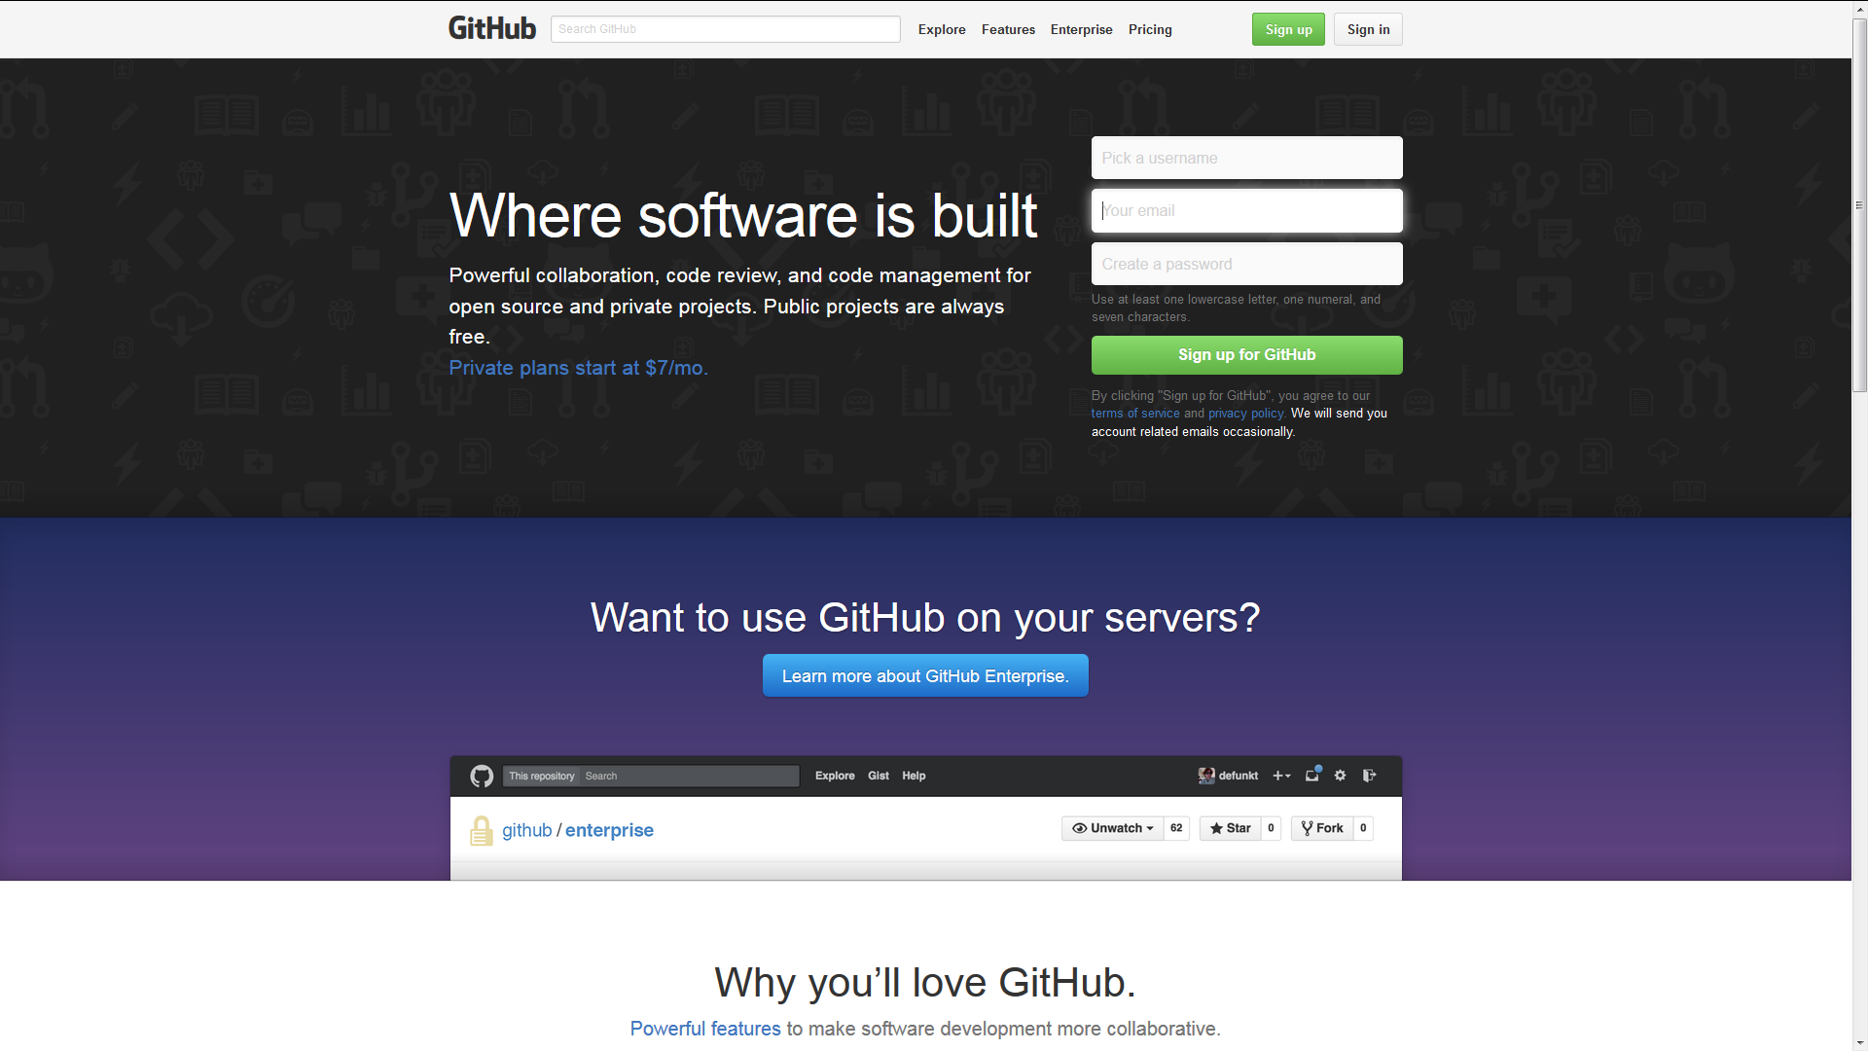

Installing GitHub

When your GitHub install file finishes downloading, go ahead and start up the installation file. If installing on windows, a security warning will likely appear. Click Run.

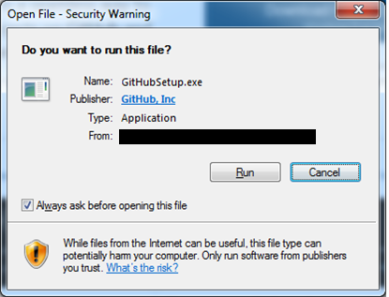

Depending on the security settings of the computer, Application Install will most likely ask about the publisher information and if it is trusted or not. Click Install.

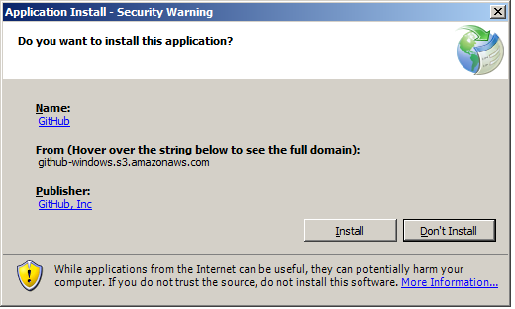

The entire process is automated. After this completes, GitHub should launch; if not, launch GitHub.

*Note: GitHub installs to the hidden folder App Data and does not allow you to choose the install location so make sure to have 300 MBs of storage.*

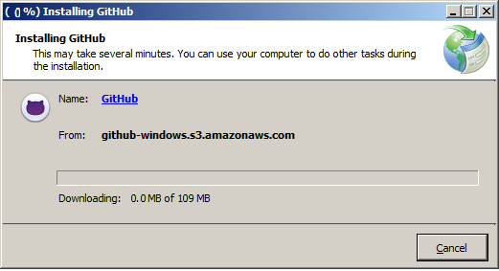

Using GitHub

First, we need to download the current repository. Click on the pulsing circle in the upper left corner of the GitHub Client.

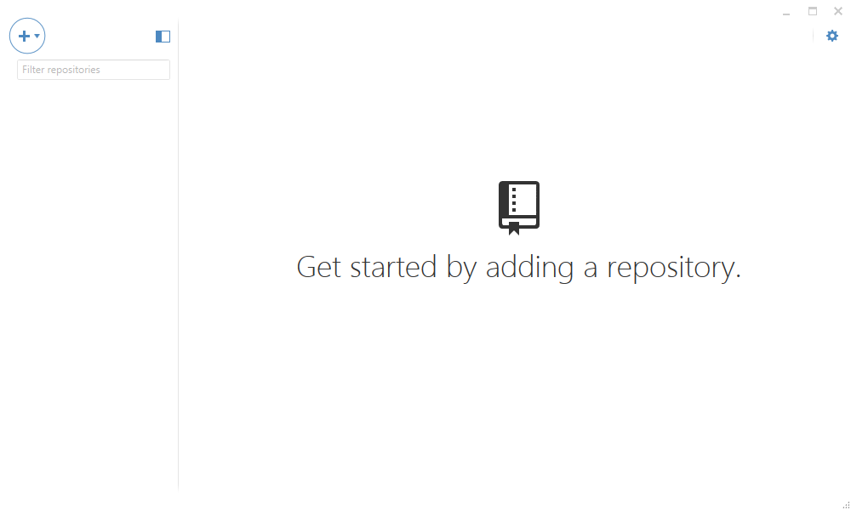

A menu will appear with a list of the repositories in which the account has access. Select BioRubeProject from the list.

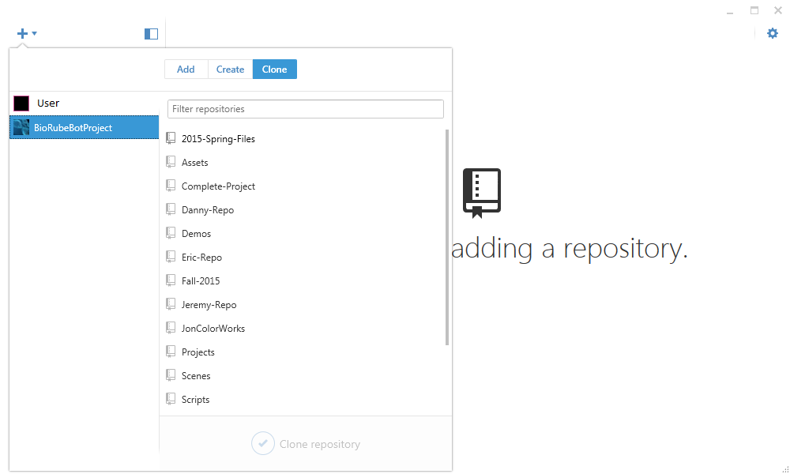

Select the desired repository on the right and click clone at the bottom.

*Note: Make sure clone is selected from the buttons at the top.*

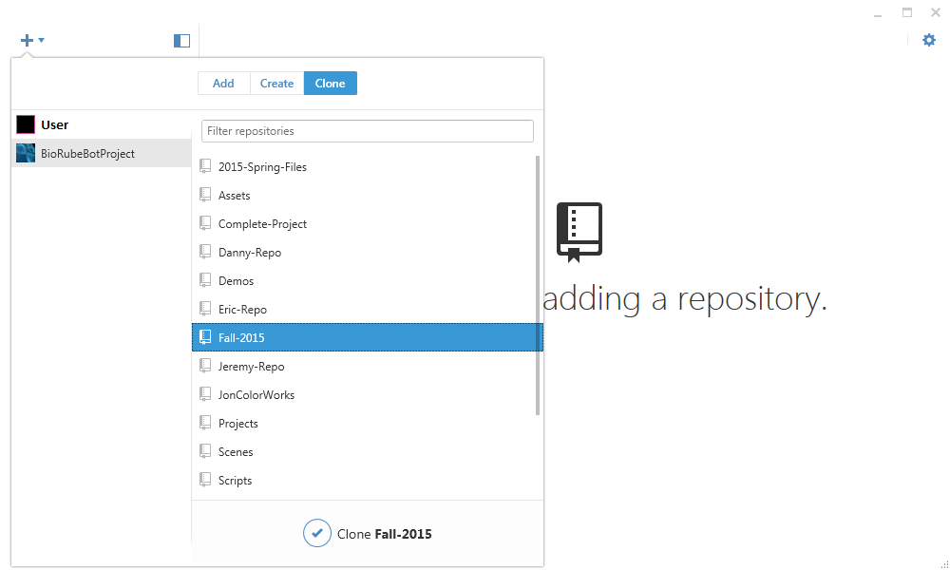

Select the location to store the local version of the repository and click ok.

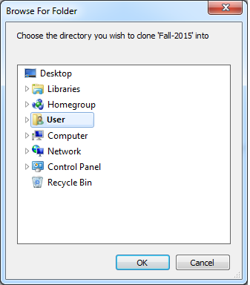

After that GitHub will show a screen like the one below stating that it is cloning the repository into the designated directory, wait for it to finish.

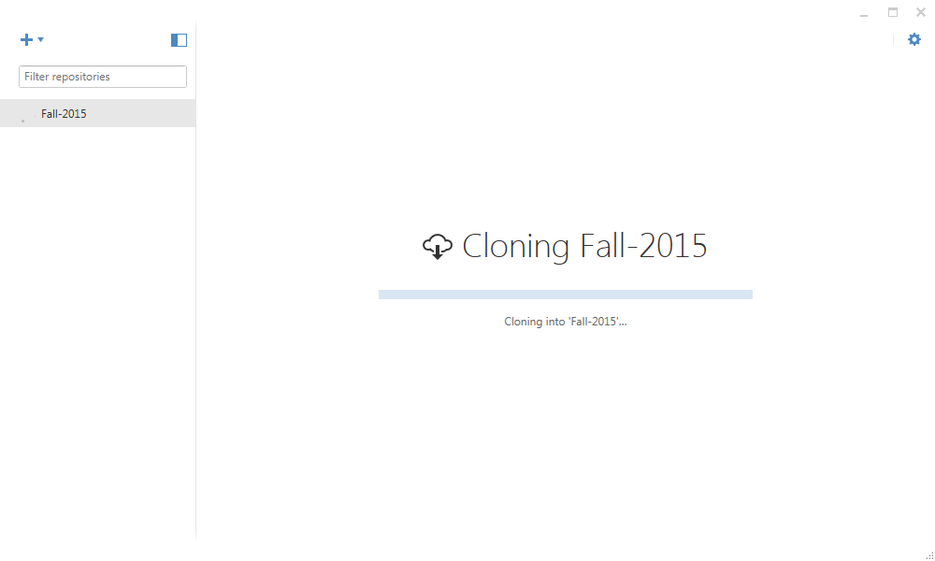

After it completes, the project is then ready to open with Unity.

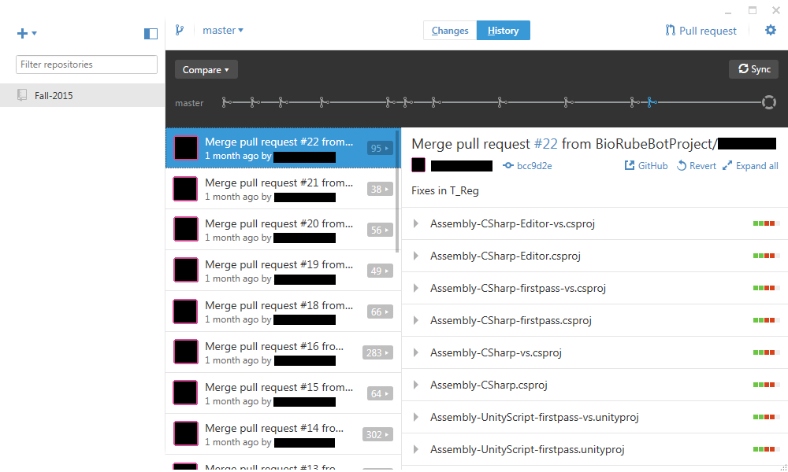

Before doing anything in Unity, Sync the specific branch of the repository in GitHub by clicking on the arrow by master at the top left. Select the branch and click Sync.

*Note: Each Developer on the project should have their own branch and no one should be using master to push/pull.*

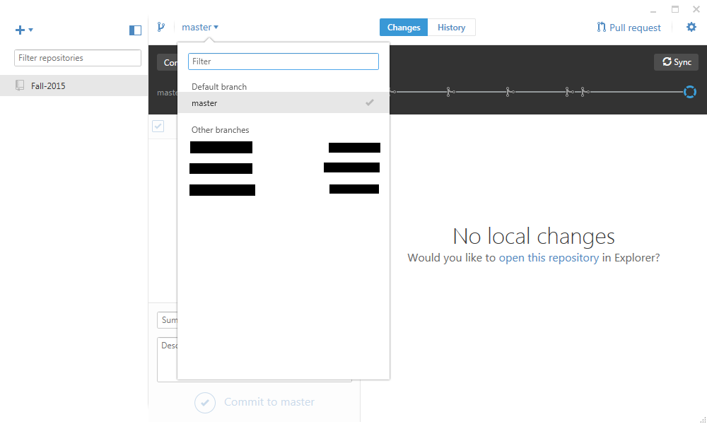

When the project is ready for your first commit, select the changed files under the changes tab to add to the commit. At the bottom, give the commit a summary title that is easily recognizable. Afterwards give a detailed list type description of every change that has been made since the last commit.

*Note: It is very beneficial to make small, frequent pushes than it is to make large, infrequent pushes. Important files include: .cs, .unity, and any other assets like scripts and sprites which have been added.*

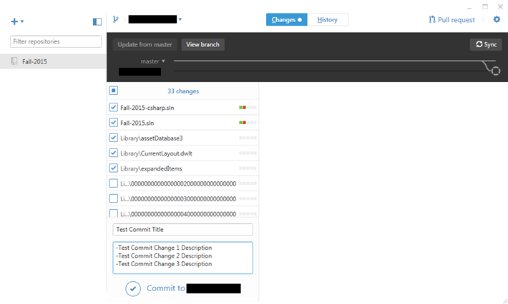

Now that the commit has been made to the local repository, it now needs to be synced with the server. Click Sync and GitHub will automatically push commits from the local repository to the GitHub Repository, and pull any changes from the GitHub repository to the local repository. Discard all other changes by right clicking on <#> changes and selecting discard all.

*Note: If a merge conflict exists, the sync will fail until the conflict is resolved. If more than one change is made to a .unity file, these changes have to be made manually in one or the other file because GitHub sees them as raw data. Same with many auto-generated files.*

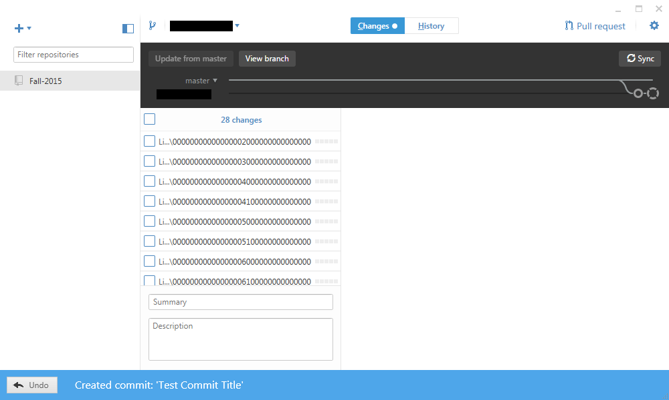

Online Documentation

* Unity
  + Unity - <https://unity3d.com>
  + Unity Tutorials - <https://unity3d.com/learn/tutorials>
  + Unity Documentation - <http://docs.unity3d.com/Manual/index.html>
  + Unity Community Hub - <https://unity3d.com/community>
  + Unity Asset Store - <https://www.assetstore.unity3d.com/en/>
* GitHub
  + GitHub - <https://github.com/>
  + GitHub Documentation - <https://developer.github.com/v3/>
* Visual Studio Tools (Note: As of Unity 5.2.x, Visual Studio Tools are now provided natively in Unity. Using one of these tools might conflict with the native version of Unity)
  + Visual Studio 2015 Tools - <https://visualstudiogallery.msdn.microsoft.com/8d26236e-4a64-4d64-8486-7df95156aba9>
  + Visual Studio 2013 Tools - <https://visualstudiogallery.msdn.microsoft.com/20b80b8c-659b-45ef-96c1-437828fe7cf2>
  + Visual Studio 2012 Tools - <https://visualstudiogallery.msdn.microsoft.com/7ab11d2a-f413-4ed6-b3de-ff1d05157714>
  + Visual Studio 2010 Tools - <https://visualstudiogallery.msdn.microsoft.com/6e536faa-ce73-494a-a746-6a14753015f1>

References

The best development platform for creating games. (n.d.). Retrieved November 27, 2015, from https://unity3d.com

GitHub. (2015, November 26). Retrieved November 27, 2015, from https://en.wikipedia.org/wiki/GitHub